**Join Meeting**

1. Once employer book and make the final payment to the employee both the user will get meeting link with meeting passcode.

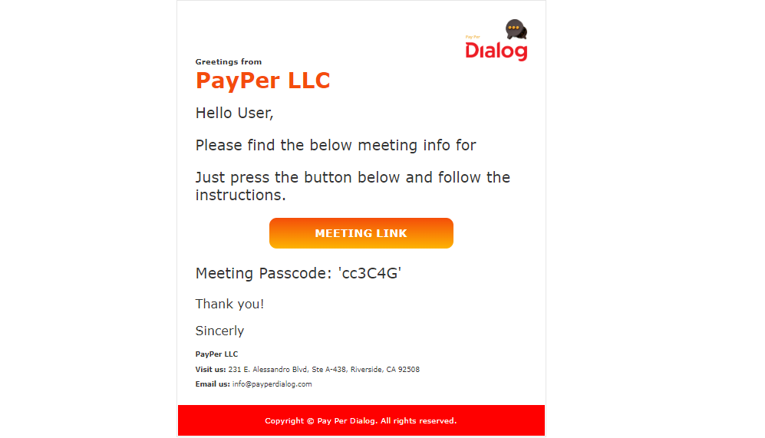

1. Once user click on the meeting link user will redirect to the join meeting page.

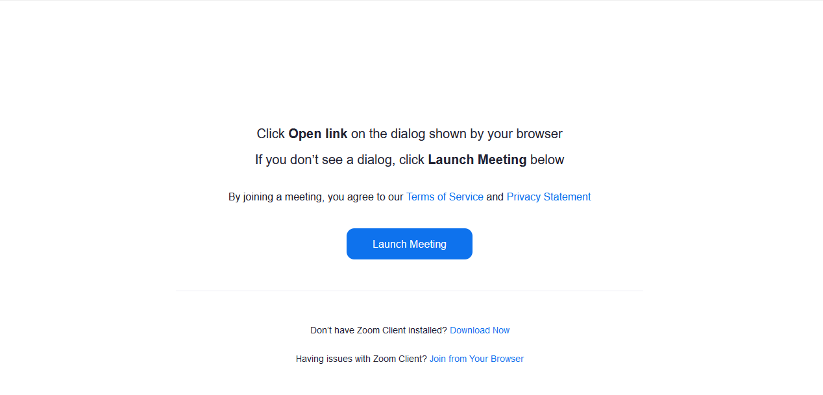

1. Once you click on the “Launch Meeting” user will get an option to “Join from your browser”.

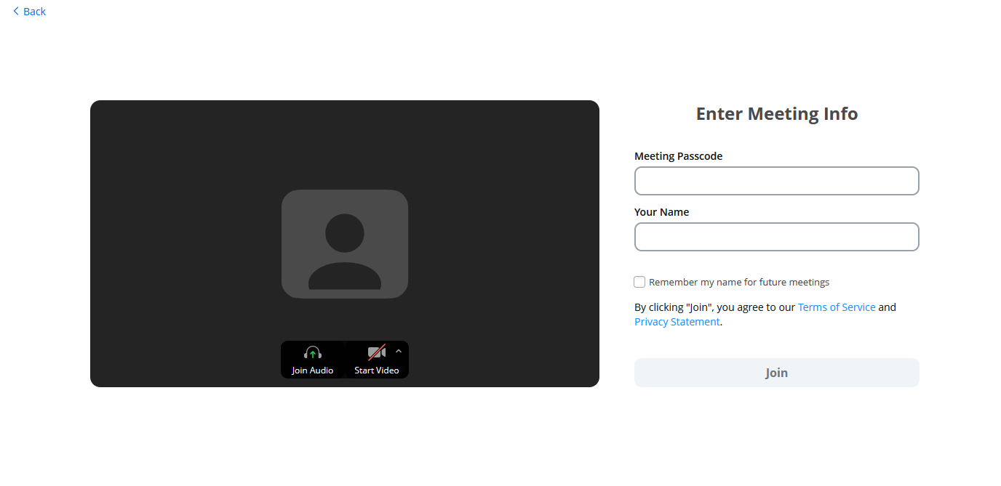

1. User need to put meeting passcode and name to join the meeting.

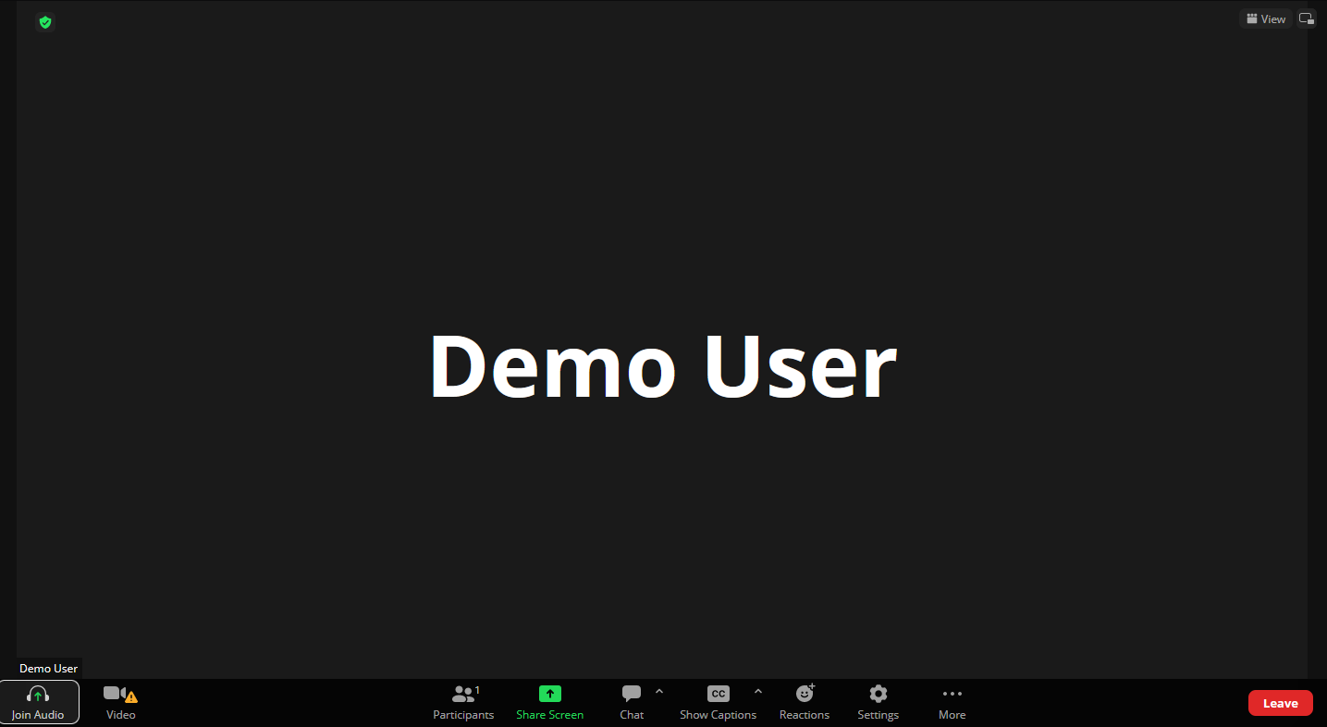

**Note: Above mentioned step is application for both Employers and employee.**